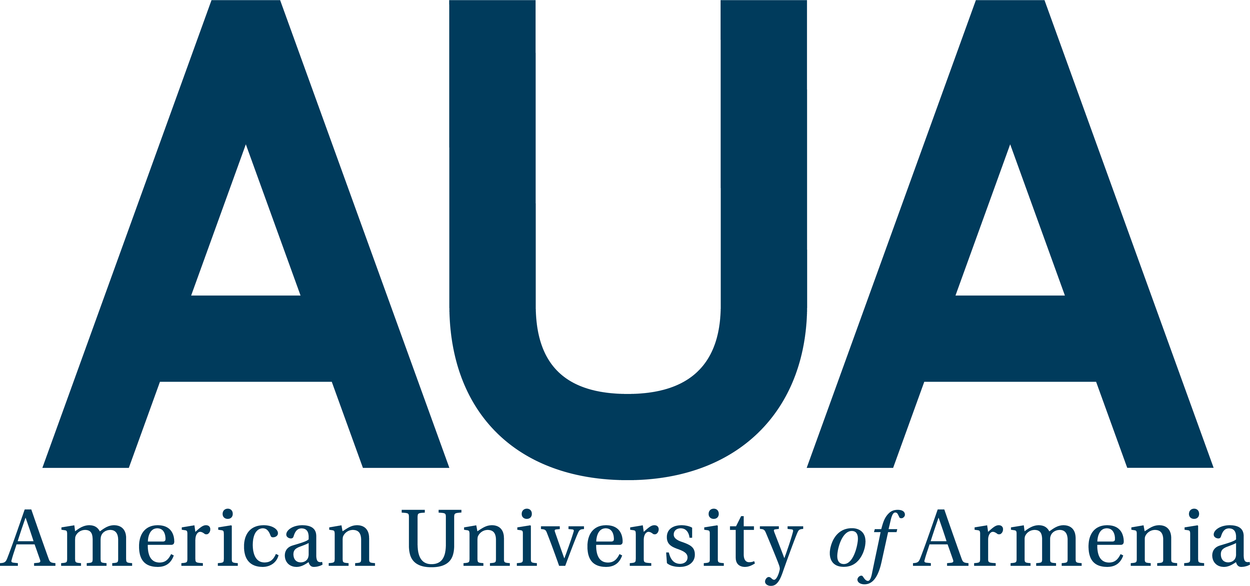
Nomination Form for
"Staff Excellence in Service" Award

The purpose of this award is to recognize the staff members who have demonstrated excellence in service during the past year. Nominations will be accepted for consideration when received by the announced deadline and when fully completed.
Nominations can be submitted by an AUA staff, faculty member or enrolled student.

Nominee Information

Name of nominee
Department
Date of nomination
Nominator Information
Name of nominator
Department
E-mail address

- Professionalism and Dedication to AUA: Using specific examples please describe and elaborate the high performance standards that the nominee has demonstrated in support of the AUA Mission. Provide examples that speak of taking initiative beyond the call of duty, making extra effort to achieve AUA strategic objectives, and demonstrating persistent diligence to enhance work processes at AUA (limit 100 words).

- Service to AUA Community: Using specific examples from your observations and experience, please describe instances or cases when the nominee has provided the AUA Community (faculty, staff, students, alumni) with outstanding support that had an impact on AUA (limit 100 words).

- Teamwork and Communication: Please briefly describe the nominee’s teamwork and communication skills (in his/her department and with other departments) and work style that support his/her nomination and clearly show that the nominee demonstrates consistently supportive, positive and timely communication, which contributes to high quality work products and excellence in team performance (limit 100 words).

