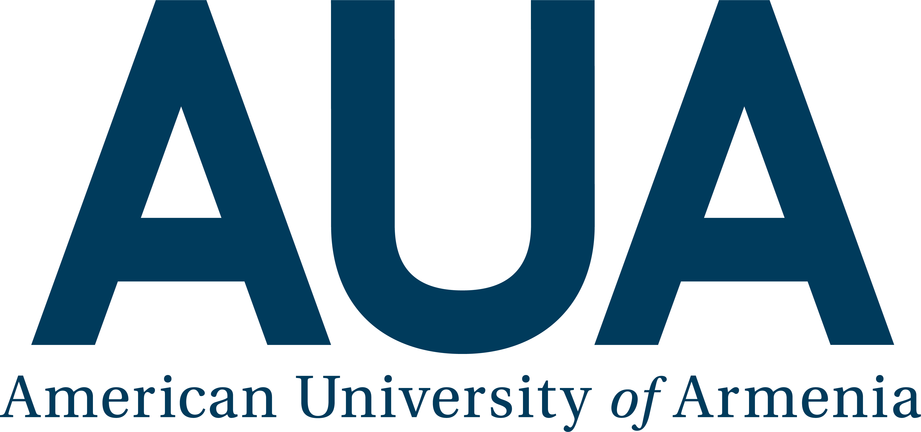
Recognizing "Staff Excellence in Service" Award
at the American University of Armenia

Overview
The American University of Armenia (AUA) offers two awards annually to staff members recognized for Excellence in Service. The Committee at the AUA will receive nominations for candidates and evaluate their eligibility for the "Staff Excellence in Service" Award.
Purpose of Award
AUA is committed to recognize excellence in service of its employees, who demonstrate their dedication to university’s strategy and core values in their every-day work. The Committee may seek and evaluate the advice of staff and faculty members as well as enrolled students in recognizing the most deserving staff members.

Nominations due by December 9, 2018, at 23:59PM
Awardees announced at AUA Christmas Party

Guidelines for Nominations
- Any staff, faculty member or current student can nominate a staff member by following links below:
      - Nomination Form Armenian
      - Nomination Form English
- Nomination can be done also by filling in and bringing to HR the hard copy of the nomination form, which you can find in AUA official web page (http://aua.am/staff/).
- The number of candidates nominated by one person is limited to three people.
- Self-nomination is not possible.
- The deadline for nomination is December 9, 2018, at 23:59PM.
Eligibility Criteria
Before nomination is approved, HR Department will check the eligibility of the nominee by the criteria presented below.
Each candidate must:
- be a full-time staff member,
- have at least 1 year of working experience at AUA,
- have a record of sustained excellence during his/her employment (no disciplinary actions, good annual performance evaluations).
Evaluation and Award Process
- The Vice President of Operations/COO has charged a Committee, including the Director of Human Resources.
- The Committee can request a Letter of Support from the nominated employee’s direct supervisor.
- All nominations received by December 9, 2018, will be reviewed by the Committee. The Committee will use pre-established rubrics for assessing nominees and ensuring impartiality in the evaluation process.
- The Committee will make its recommendation to the Vice President of Operations and President by December 19, 2018.
- The awardees will be honored at the AUA Christmas Party.

